L22: Preparation Assignment Worked Solutions 221 A
Part I: Concepts
- What is simple linear regression? Explain.
Simple Linear Regression allows us to write a linear equation that models the relationship between the independent variable (X) and the dependent variable (Y).
- What is the formula in the Online Textbook in terms of $\hat{Y}, b_{0}, b_{1}$and$X$which represents the linear equation used to estimate a line relating the variables X and Y (assuming a linear relation exists between these two variables).
$$\hat{Y}= b_{o}+ b_{1}X$$

y-intercept Slope
- For the line: $Y= 1.34-2.2X$, what is the slope?
Slope = -2.2
- For the line: $Y= 1.34-2.2X$, what is the $Y$-intercept?
Y-intercept = 1.34
- Using the prediction line above in #4, predict the value of $Y$ for the input value of $X=5.$
$$y=1.34-2.2\left(5\right)= -9.66$$

Part II: Application To answer the following questions, use the Gharial Crocodiles Data in the Online Textbook under the data link in Course Resources.

- What is the Explanatory Variable? (You will need to review the section in the Online Textbook on the crocodiles to answer this question)
Head Length

- What is the Response Variable? (You will need to review the section in the Online Textbook on the crocodiles to answer this question)
Body Length

- Create a scatter plot representing the relationship between Head Length and Body Length. Paste your plot below.

Students scatter plot should look like this. This can be made using the excel spreadsheet Quantitative Inference Procedures. First open the data set Gharial Crocodiles, and copy and paste the head length in for the explanatory variable (x) and copy and paste the body length in for the response variable (y). This will give you the scatter plot above.

- Use the software to compute the value of the y-intercept in the regression line.
y-intercept = -69.369
This is also found using the same steps as in question 3. The y-intercept is found in the box that is labeled y-int ($b_{o})$, or cell H13.
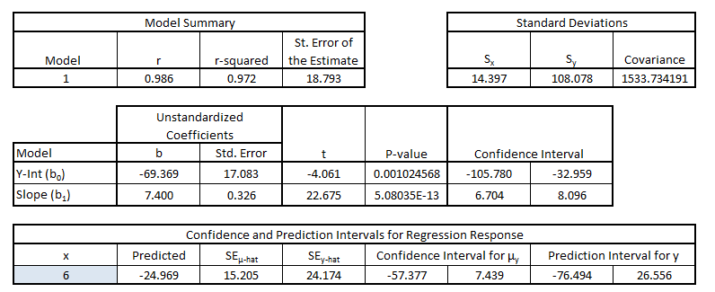
Y-intercept Slope
- Use the software to compute the slope of the regression line.

Slope = 7.4
The slope is found next to the box labeled Slope ${(b}_{1})$ or cell H14.

- What is the equation for the regression line computed by the software?

$$\hat{y}= -69.369+7.4x$$
This is found by simply inputting the y-intercept and slope to the Linear regression equation.

- Use the software to draw the regression line on the scatter plot. Insert the picture of scatter plot with graph of the regression line superimposed over the data.

This is done by right clicking on any of the data points in the scatter plot that you created earlier in the excel spreadsheet Quantitative Inference Procedures. Then select the option “Add trendline”. Make sure the Linear circle is checked, then click done.

- For the observed head length of 51 cm, what is the observed body length? (Look in the data file to find this answer.)

Observed body length = 343 cm

This is found by just looking in the Data file Gharial Crocodile.xlsx.

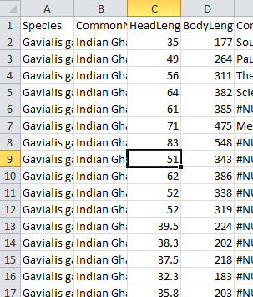

- Use the regression line you obtained in #2 above to predict the body length based on a head length of 51 cm.

$$\hat{y}= -69.369+7.4\left(51\right)=308.031 cm$$
Simply plug in 51 for X in your linear regression equation. Answers will vary between 300 and 350.
- Why are the values you obtained in #8 and #9 different? Explain.

The values are different because the points are not all exactly on the line of best fit. If you look at the graph, visually you can see that the actual point of 51 cm is notably above the line. The line equation is the best estimate but it is not the actual observed measurements.

